Task 1

Product Boundary Use Case Diagram.

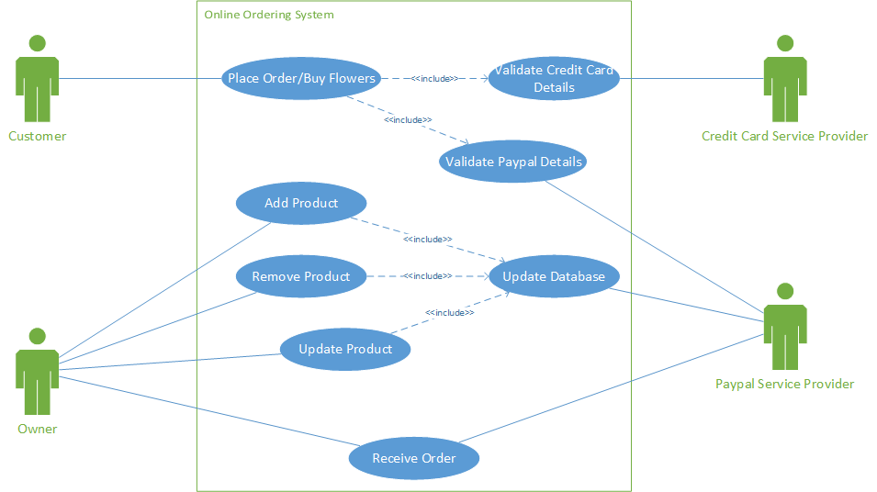

Product Use Case List

* Receive Order: The staff owner receives an email and fax after the buyCuser pays for item.
* Update Product: To update products on the website.
* Remove product: To remove a product from the website.
* Add product: To add products on the website.
* Place Order/buy flowers: Customer wants to buy products online
* Validate credit card Details: Credit Card provider validates credit details.
* Validate PayPal Details: PayPal validates PayPal/credit information.
* Update Database: Update database with information provided.

**Use Cases:**

Happy scenario

The customer goes on to the website.

Picks an item which then is purchased via the PayPal system.

Enters details such as credit card and the address of the recipient the product will be to send to.

PayPal processes the order.

Emails are sent to customer and staff

Falco sends a fax to the staff in the shop.

The staff make up customers order which is then Delivered to the customer, smiles all round.

Wrong Scenario

The customer visits the website.

Picks an item which is bought using PayPal.

Enters details such as credit card and address details to send to.

Wrong details entered, asked to try again.

No funds scenario

The customer goes on to the website.

Picks an item Is brought to PayPal.

Enters details such as credit card and address to send to.

No money in credit card or PayPal credit.

Asked to enter other details.

|  |  |
| --- | --- |
| USE CASE NAME: | Buy flowers |
| USE CASE ID: | UC3 |
| PRIORITY: | Normal |
| SOURCE: | Owner |
| PRIMARY BUSINESS ACTOR: | Online customer |
| OTHER PARTICIPATING ACTORS: | PayPal |
| OTHER INTERESTED STAKEHOLDERS: | Staff |
| DESCRIPTION: | Customer wants to buy products online |
| PRE-CONDITION: | Has to have credit card/PayPal account |
| TRIGGER: | Need to buy flowers |

|  |  |  |
| --- | --- | --- |
| TYPICAL COURSE OF EVENTS: | **Actor Action** | **System Response** |
| Step 1: | Customer browse business **website** | System displays **home page** |
| Step2: | Customer selects Add to Cart | System will display selected item and payment options |
| Step 3: | Customer select PayPal payment | System display PayPal Login dialogue box |
| Step 4: | Customer Login | System display payment details and confirmation button |
| Step 5: | Customer confirms order | System displays confirmation details back |
| **Step 6:** | Customer press confirm | System displays successful order |

|  |  |  |
| --- | --- | --- |
| **Sub Flows** | **Actor Action** | **System Response** |
| at Step 2 | Customer wants to add more items | System displays Home page |
|  | Customer adds another item | System will display selected item and payment options |

|  |  |  |
| --- | --- | --- |
| **ALTERNATE COURSES:** | **Actor Action** | **System Response** |
| at Step 3 | customer selects credit card payment options | System display credit card validation form |
|  | Customer enters credit card | System display payment details and confirmation button |
|  | customer confirms order | System displays home page |
| at Step 2 | Customer cancels the order | System displays order details remove and continue to home page |

|  |  |
| --- | --- |
| CONCLUSION: |  |
| POSTCONDITION: | Email is sent to the business and customer |
| BUSINESS RULES | The customer has to have a credit card/PayPal |
| IMPLEMENTATION CONSTRAINTS AND SPECIFICATIONS | Customer has to have internet connection |
| ASSUMPTIONS: | None |
| OPEN ISSUES: | PayPal/credit card fail |
| Special Requirements | None |
| Additional Information | none |

|  |  |
| --- | --- |
| **USE CASE NAME:** | Add new Products on Website |
| **USE CASE ID:** | UC1 |
| **PRIORITY:** | N/A |
| **PRIMARY BUSINESS ACTOR:** | Owner |
| **OTHER PARTICIPATING ACTORS:** | Staff |
| **OTHER INTERESTED STAKEHOLDERS:** | Online customers |
| **DESCRIPTION:** | To add products on the website. |
| **PRE-CONDITION:** | Has to be logged in, Has internet connection. |
| **TRIGGER:** | Has a new product to update on website |

|  |  |  |
| --- | --- | --- |
| **TYPICAL COURSE OF EVENTS:** | **Actor Action** | **System Response** |
| **Step 1**: | User logs in | System displays admin screen with additional options such as view traffic |
| **Step2**: | User clicks addnew product button | System displays form to be filled out with criteria to add a new product (title, price, PayPal link and photo). |
| **Step 3**: | User fills information | System takes input |
| **Step 4**: | User clicks save. | System saves information to database. |

|  |  |  |
| --- | --- | --- |
| **Sub Flows** | **Actor Action** | **System Response** |
| PayPal extend step 2 | Logs into PayPal | Displays PayPal options home screen |
|  | User clicks add new product | System displays form to be filled out with criteria to add a new product (such price and details) |
|  | User click Saves | Systems saves and refreshes to the home screen. |
|  | User Now has access to the PayPal link |  |

|  |  |  |
| --- | --- | --- |
| **ALTERNATE COURSES:** | **Actor Action** | **System Response** |
| At Step 3 inputting information | User clicks submit with missing criteria | System refreshes page displaying input missing |
| At Step 4 , Adding duplicate Products | User tries to input duplicate item | System refreshes page displaying message about duplicate item. |
| At all steps , System failure | System crashes while user is trying to update | System tries to save information locally for when it goes back online. |

|  |  |
| --- | --- |
| **CONCLUSION:** | None |
| **POSTCONDITION:** | None |
| **BUSINESS RULES** | None |
| **IMPLEMENTATION CONSTRAINTS AND SPECIFICATIONS** | None |
| **ASSUMPTIONS:** | None |
| **OPEN ISSUES:** | Database Errors |
| Special Requirements | Must have a new product to add to website. Must also have changes to website. |
| Additional Information | Need to be verify which information should displayed or should not be displayed |

|  |  |
| --- | --- |
| **USE CASE NAME:** | Update Products on Website |
| **USE CASE ID:** | 1 |
| **PRIORITY:** | N/A |
| **PRIMARY BUSINESS ACTOR:** | Owner |
| **OTHER PARTICIPATING ACTORS:** | Staff |
| **OTHER INTERESTED STAKEHOLDERS:** | Buyers |
| **DESCRIPTION:** | To update products on the website. |
| **PRE-CONDITION:** | Has to be logged in, Has internet connection. |
| **TRIGGER:** | Has a product they wish to update on website. |

|  |  |  |
| --- | --- | --- |
| **TYPICAL COURSE OF EVENTS:** | **Actor Action** | **System Response** |
| **Step 1**: | User logs in | System displays admin screen with additional options such as view traffic |
| **Step2**: | User clicks update product button | System displays form to be filled out with criteria to update a product (title, price, PayPal link and photo). |
| **Step 3**: | User enters Product Id Number | System refreshes and fill form with product information from database where id matches |
| **Step 4**: | User Makes changes | System makes changes |
| **Step 5** | User clicks save. | System saves information to database and updates projects. |

|  |  |  |
| --- | --- | --- |
| **Sub Flows** | **Actor Action** | **System Response** |
| PayPal extend step 4 | Logs into PayPal | Displays PayPal options home screen |
|  | User clicks add update product input id of product | System displays form to be filled out with criteria to update product (such price and details). |
|  | User inputs updated information | System feedback |
|  | User click Saves | Systems saves and refreshes to the home screen. |
|  | User has now updated the product |  |

|  |  |  |
| --- | --- | --- |
| **ALTERNATE COURSES:** | **Actor Action** | **System Response** |
|  | None | None |

|  |  |
| --- | --- |
| **CONCLUSION:** | None |
| **POSTCONDITION:** | None |
| **BUSINESS RULES** | None |
| **IMPLEMENTATION CONSTRAINTS AND SPECIFICATIONS** | None |
| **ASSUMPTIONS:** | None |
| **OPEN ISSUES:** | Database Errors |
| Special Requirements | Must have a product they wish to update on website. |
| Additional Information | Need to be verify which information should displayed or should not be displayed |

|  |  |
| --- | --- |
| **USE CASE NAME:** | Remove Products on Website |
| **USE CASE ID:** | 1 |
| **PRIORITY:** | N/A |
| **PRIMARY BUSINESS ACTOR:** | Owner |
| **OTHER PARTICIPATING ACTORS:** | Staff |
| **OTHER INTERESTED STAKEHOLDERS:** | Buyers |
| **DESCRIPTION:** | To remove a product from the website. |
| **PRE-CONDITION:** | Has to be logged in, Has internet connection. |
| **TRIGGER:** | Has a product they wish to remove from website. |

|  |  |  |
| --- | --- | --- |
| **TYPICAL COURSE OF EVENTS:** | **Actor Action** | **System Response** |
| **Step 1**: | User logs in | System displays admin screen with additional options such as view traffic |
| **Step2**: | User clicks remove product button | System displays form to be filled out product Id |
| **Step 3**: | User enters Product Id Number | System refreshes and asks if they wish to remove this product. |
| **Step 4**: | User inputs choose | System makes changes |
| **Step 5** | User clicks save. | System saves information to database and removes projects. |

|  |  |  |
| --- | --- | --- |
| **Sub Flows** | **Actor Action** | **System Response** |
| PayPal extend step 5 | Logs into PayPal | Displays PayPal options home screen |
|  | User clicks remove product button and inputs id of product | System displays form of the product information from the user wishes to remove. |
| Step5 | User click remove | Systems removes product and refreshes to the home screen. |
|  | User has now removed the product |  |

|  |  |  |
| --- | --- | --- |
| **ALTERNATE COURSES:** | **Actor Action** | **System Response** |
| At step5: remove product option | User clicks cancel | System refresh to the home screen |
| At step4: remove product option | User clicks cancel | System refresh to the home screen |

|  |  |
| --- | --- |
| **CONCLUSION:** | None |
| **POSTCONDITION:** | None |
| **BUSINESS RULES** | None |
| **IMPLEMENTATION CONSTRAINTS AND SPECIFICATIONS** | None |
| **ASSUMPTIONS:** | None |
| **OPEN ISSUES:** | Database Errors |
| Special Requirements | Must have a product they wish to update on website. |
| Additional Information | Need to be verify which information should displayed or should not be displayed |

|  |  |
| --- | --- |
| **USE CASE NAME:** | Receive Orders |
| **USE CASE ID:** | UC 2 |
| **PRIORITY:** | High |
| **SOURCE:** | Client |
| **PRIMARY BUSINESS ACTOR:** | Owner |
| **OTHER PARTICIPATING ACTORS:** | Staff involved in the delivery  System holding email account  FaxCo |
| **OTHER INTERESTED STAKEHOLDERS:** | People buying the flowers |
| **DESCRIPTION:** | The staff, owner wants to check the email received after the buyer pays for item. |
| **PRE-CONDITION:** | The user must hold email account |
| **TRIGGER:** | Payment received |

|  |  |  |
| --- | --- | --- |
| **TYPICAL COURSE OF EVENTS:** | **Actor Action** | **System Response** |
| **Step 1**: | User browse to email account | System displays log in box |
| **Step2**: | User logs in | System displays list of emails |
| **Step 3**: | User logs out | System closes email list |

|  |  |  |
| --- | --- | --- |
| **ALTERNATE COURSES:** | **Actor Action** | **System Response** |
| At step 2: | user provides incorrect login details | System prompts to re enter the details |

|  |  |
| --- | --- |
| POSTCONDITION: | None |
| BUSINESS RULES | None |
| ASSUMPTIONS: | None |
| OPEN ISSUES: | Connection to email account may fail |

Task 2

Post Primary Requirements

* To be able to update, remove and add product within 2 to 4 clicks away from the home screen.
* The sample should be straightforward and easy to use.
* Must ask for id, name, and description, upload a photo and PayPal links.
* Able to view information before changing products.

Home Screen

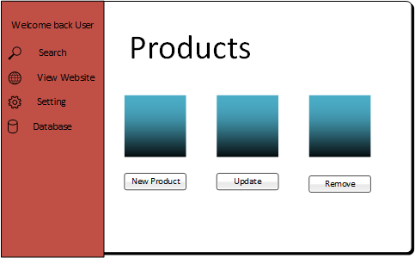

Add Product

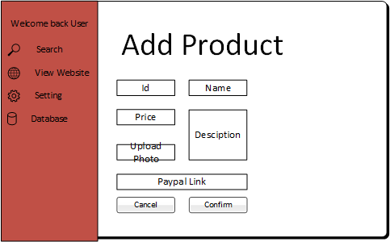

Remove Product

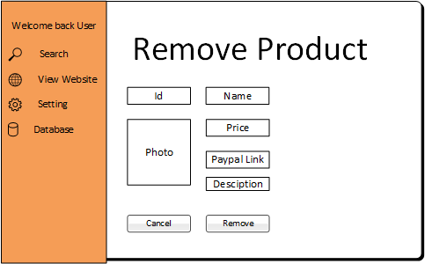

Update Product

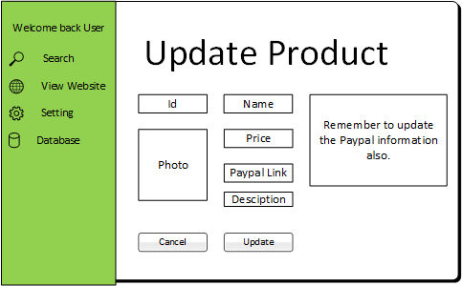

Final Requirements (Same as above)

* To be able to update, remove and add product within 2/4 clicks away from the home screen.
* The sample should be straightforward and easy to use.
* Must ask for id, name, and description, upload a photo and PayPal links.
* Able to view information before changing products.